1. What do these results show about the effect of the new system?
2. Would you recommend further experiment?

However, you may need to address the following two questions in order for you to analyze the above problems:

* Do these data show that the new computer system reduced the time spent on *Nurses’ Administration*?
* Do the data show that the new computer system enabled nurses to spend more time on *Direct Patient Care*?

Why two sample test ?

* In statistics, t-tests are a type of hypothesis test that allows you to compare means.
* Signal / noise analogy

The One Sample *t* Test determines whether the sample mean is statistically different from a known or hypothesized population mean.

The paired t-test and the 1-sample t-test are actually the same test in disguise! As we saw above, a 1-sample t-test compares one sample mean to a null hypothesis value. A paired t-test simply calculates the difference between paired observations (e.g., before and after) and then performs a 1-sample t-test on the differences.

The 2-sample t-test takes your sample data from two groups and boils it down to the t-value. The process is very similar to the 1-sample t-test, and you can still use the analogy of the signal-to-noise ratio. Unlike the paired t-test, the 2-sample t-test requires independent groups for each sample.

The default null hypothesis for a 2-sample t-test is that the two groups are equal. You can see in the equation that when the two groups are equal, the difference (and the entire ratio) also equals zero. As the difference between the two groups grows in either a positive or negative direction, the signal becomes stronger.

Go through the formula

When running a two-sample equal-variance t-test, the basic assumptions are that the distributions of the two populations are normal, and that the variances of the two distributions are the same.

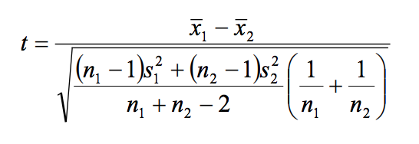

difference in means / sqrt (variance / sample size)

|  |  |  |  |  |
| --- | --- | --- | --- | --- |
| Nurse Type | Direct Care | Non-Nursing | Indirect Care | Nurse’s Admin |
| RN | 0.76 | 0.33 | 0.84 | 0.25 |
| NA | 0.23 | 0.30 | 0.66 | 0.19 |

Table1: p-values for Bartlett test of homogeneity of variances

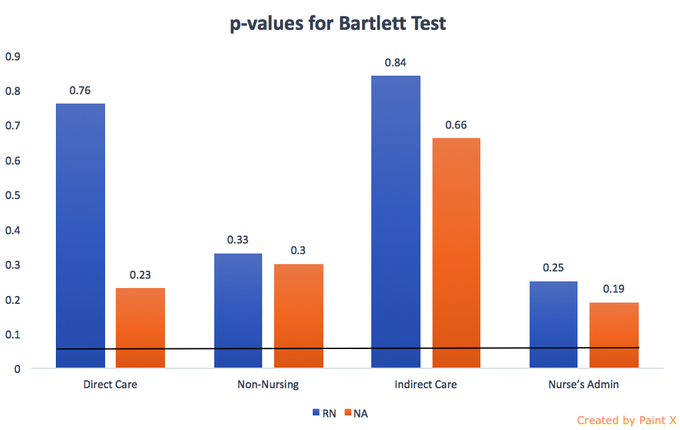

|  |  |  |  |  |
| --- | --- | --- | --- | --- |
| Nurse Type | Direct Care | Non-Nursing | Indirect Care | Nurse’s Admin |
| t-values | | | | |
| RN | -1.58 | -1.38 | 2.02 | 1.39 |
| NA | -1.62 | 0.06 | 1.77 | 3.09 |
| p-values | | | | |
| RN | 0.12 | 0.17 | 0.05 | 0.17 |
| NA | 0.12 | 0.95 | 0.09 | 0.005 |

Table2: t & p-values for each category of two samples

